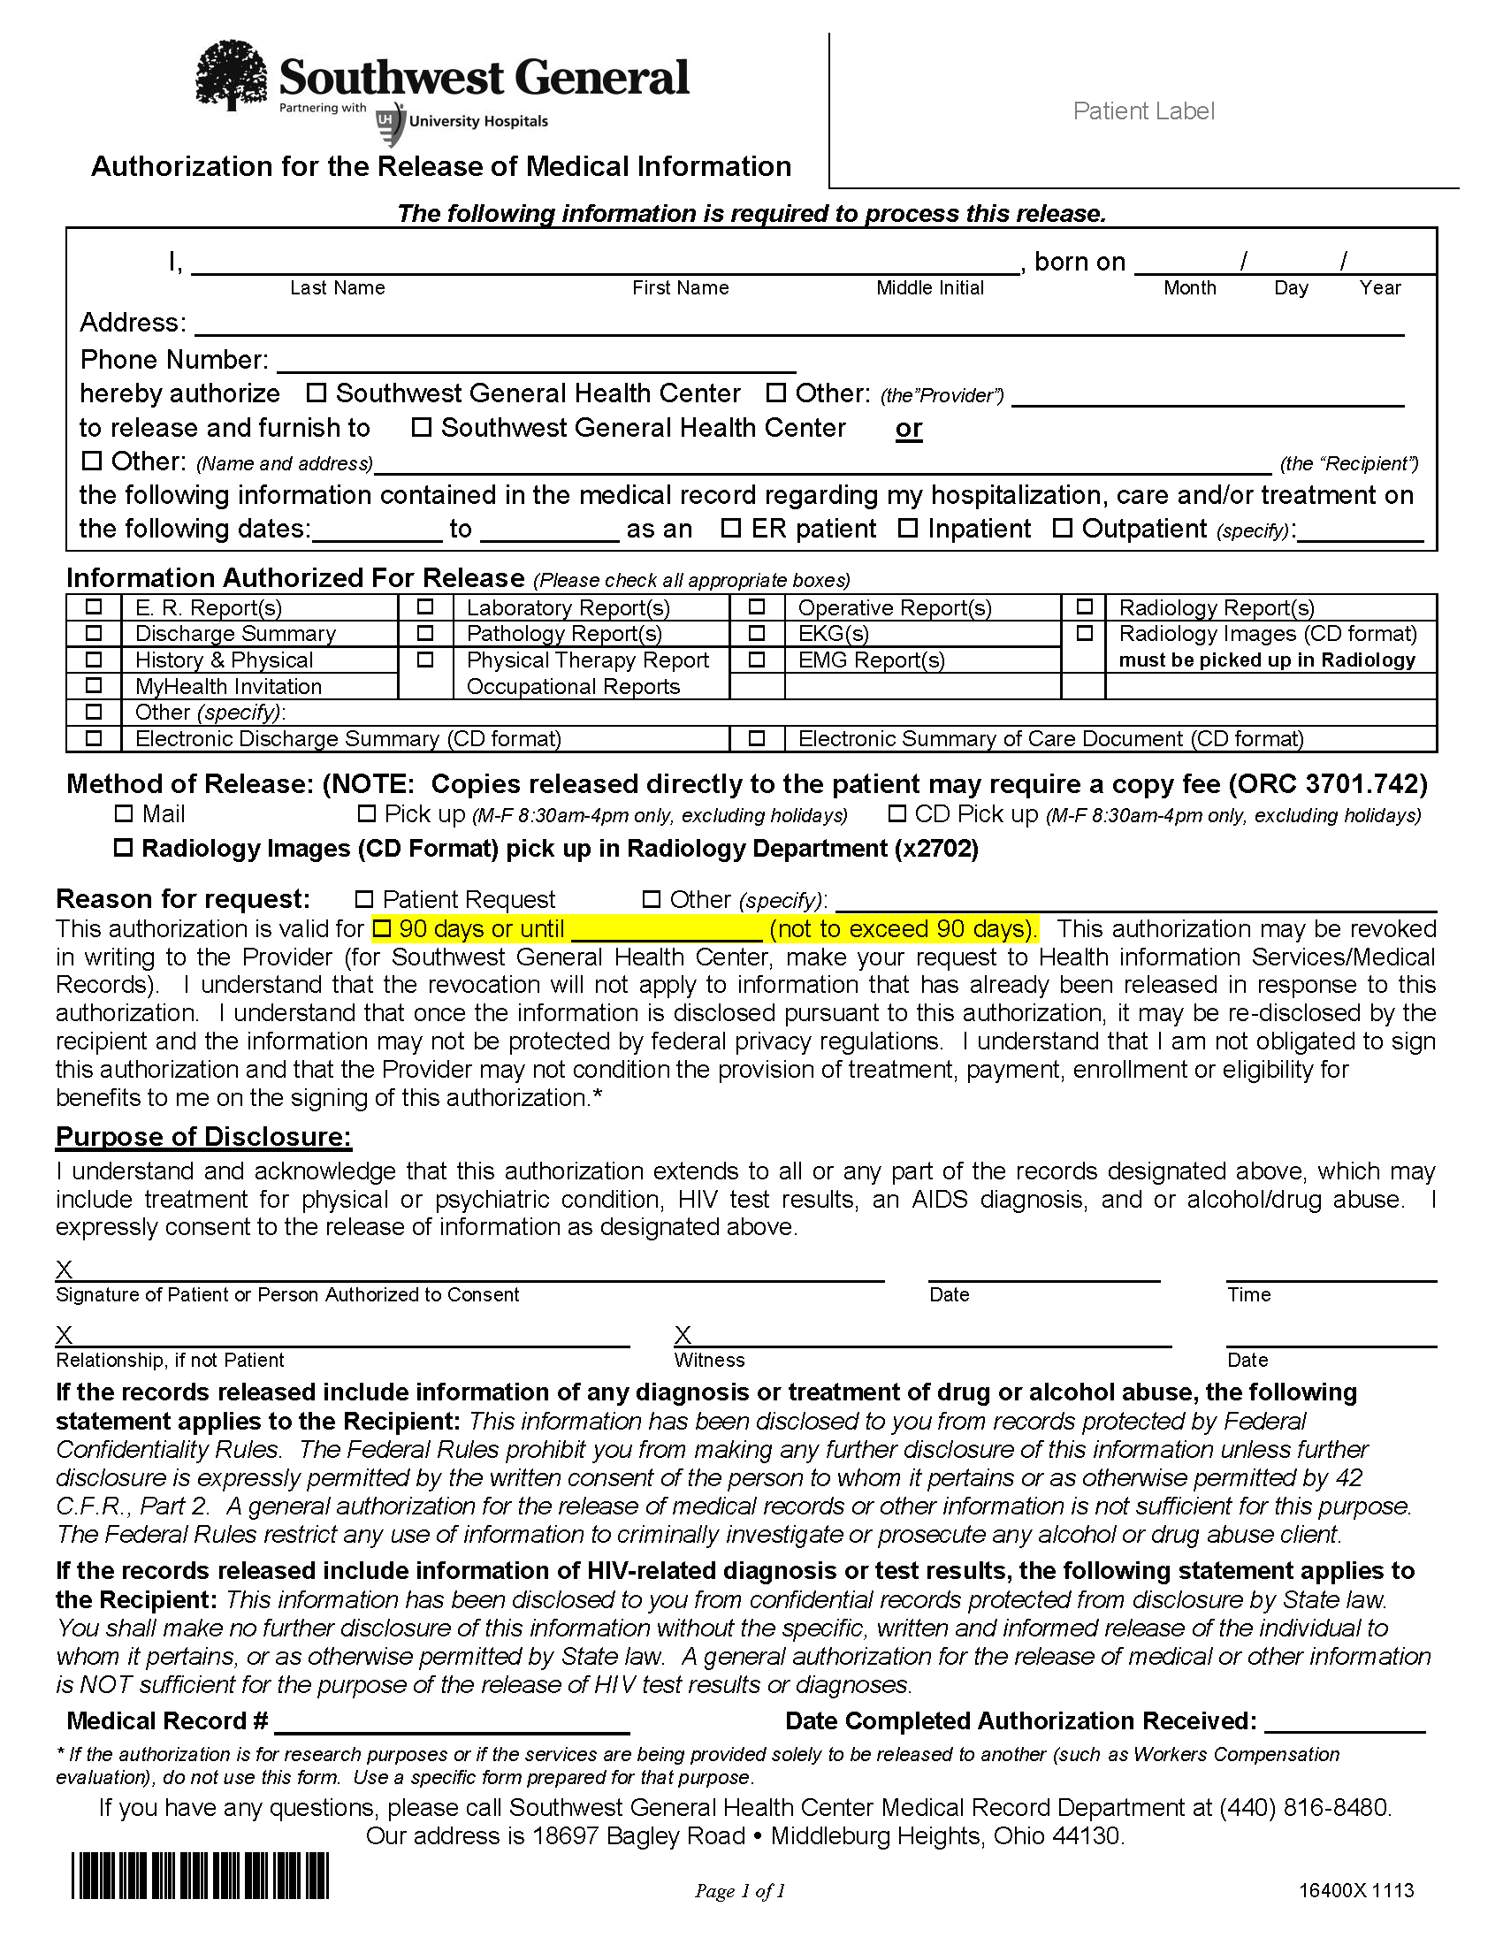
Batman
Secret Location Under Office Building Gotham, NJ
01/01/1979
Axiom Requisition Copy Service - 2869 Jolly Road Okemos, MI 48864
x

